PHASE 1: Environment Setup (Day 1)

Step 1.1: Install Required Software
- Check Java (required for Kafka)
- Download java from: https://www.oracle.com/java/technologies/downloads/
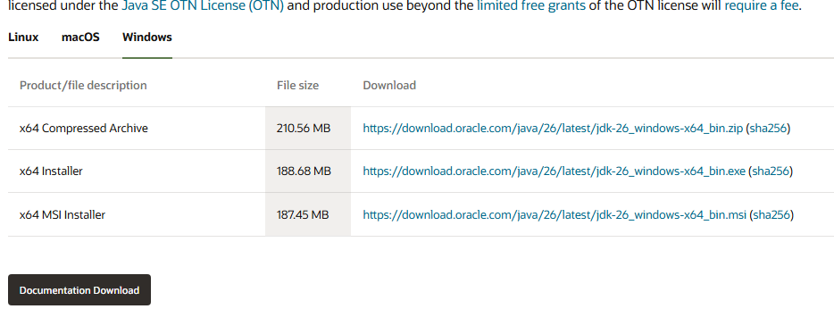

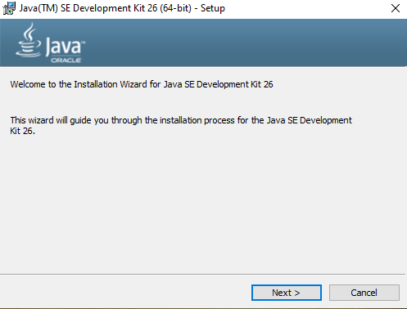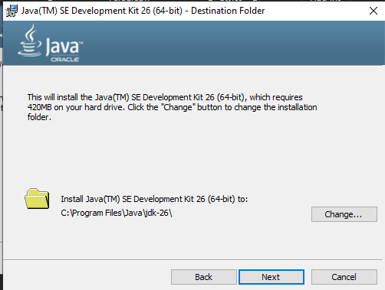

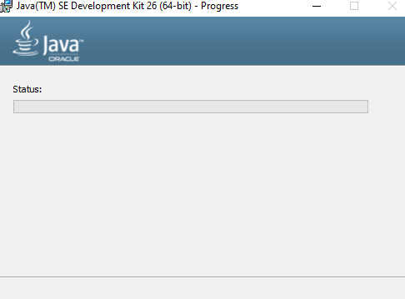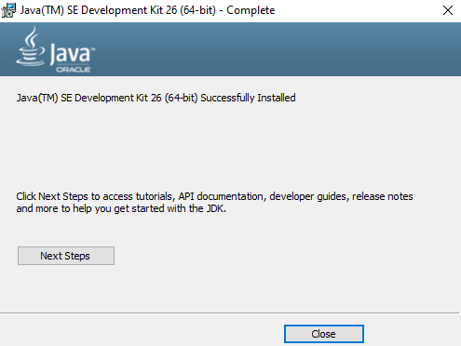

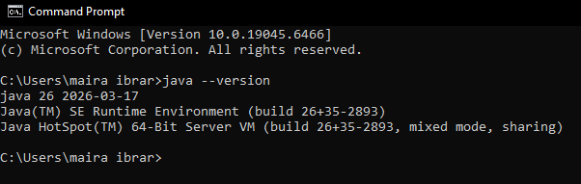
- Check Python
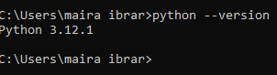

Step 1.2: Create Project Folder Structure
- Create main project folder
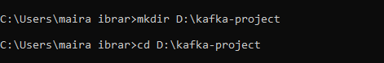
- Create all sub-folders
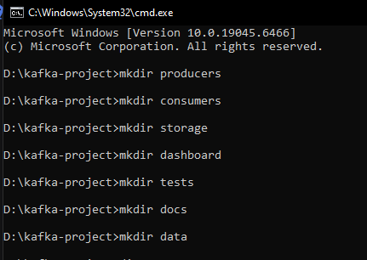
- Verify folders created
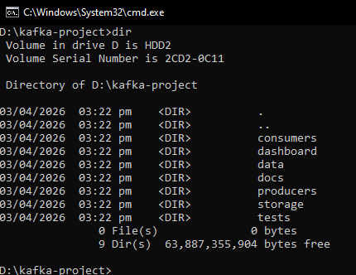

Step 2: Python Virtual Environment on D: Drive
- Make sure you're in D: drive
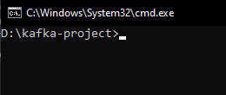
- Create virtual environment

- Verify venv created
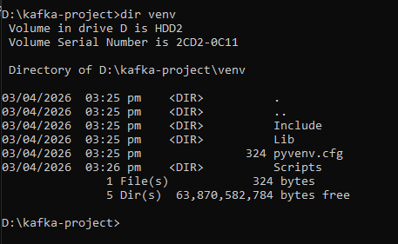
- Activate virtual environment
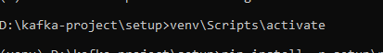
- You should see this in terminal:
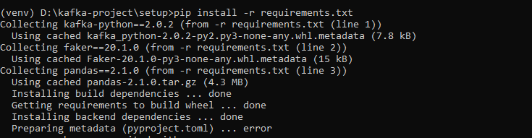

Step 3: Create Requirements File
- Using echo command
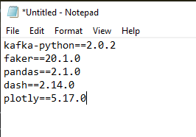

Step 4: Install All Packages
- Make sure venv is activated
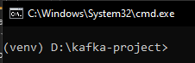
- Install from requirements file
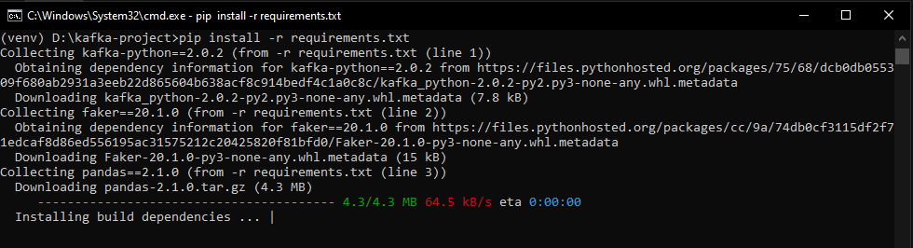
- Verify installations
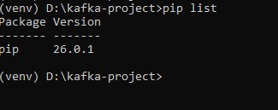

Step 5: Download Kafka on D: Drive
- Create Kafka folder on D: drive
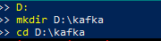
- Download Kafka 4.2.0
- Extract the file
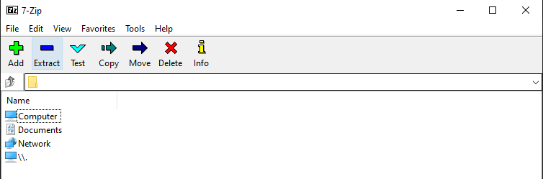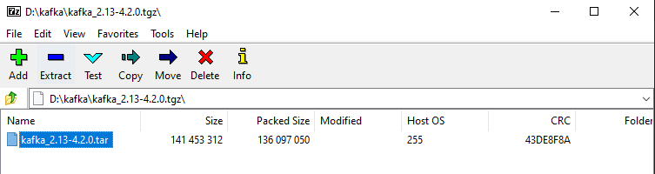
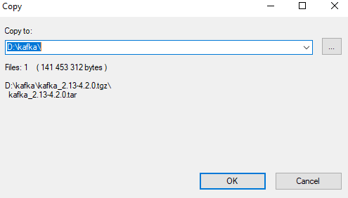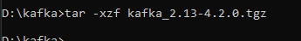
- Create data directories
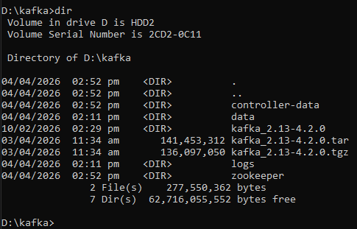

Step 6: Configure Kafka for D: Drive
- Update Server Properties
- Change these lines:
- # Update this line (around line 60)
log.dirs=D:/kafka/kafka/data
- # Update this line (around line 30)
listeners=PLAINTEXT://localhost:9092

- Change
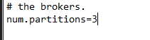
- Update ZooKeeper Properties
- Change this line:
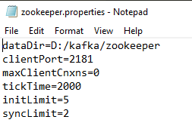
- Find where logs are written and change to D: drive:
- Change this line:
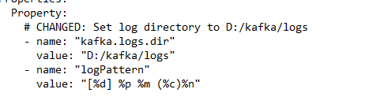

Step 7: Create Startup Scripts
start_kafka.bat stop_kafka.bat
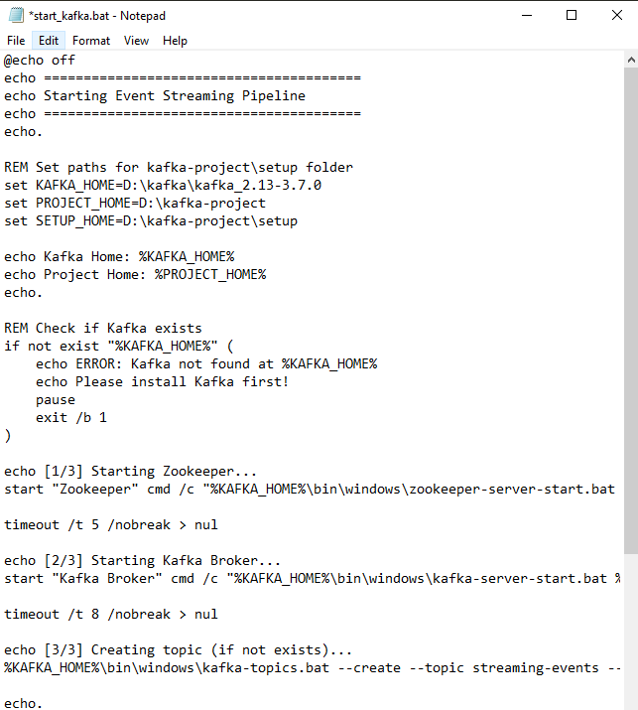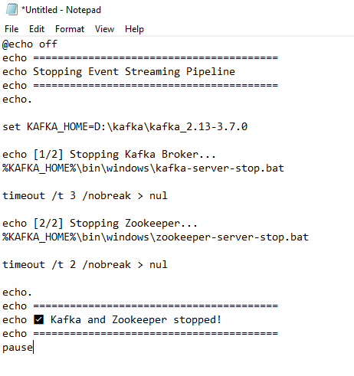
check_kafka.bat

